Step 1: Go to link <https://ubuntu.com/tutorials/how-to-run-ubuntu-desktop-on-a-virtual-machine-using-virtualbox#1-overview> in your browser. Scroll down to you see where you click “here” (see yellow highlighted below) for downloading an image of Ubuntu:

Step 2: Clicked green Download button (this will take some time to download):

Note: If you already installed VirtualBox, you can skip to step 11 (page 6).

Step 3: Visit <https://www.virtualbox.org/> and click on “Download VirtualBox” blue button:

Step 4: Click on “Windows hosts” below, then an executable will download:

Step 5: Click on the executable once it is downloaded, and then click “Yes” for the User Account Control window that pops up. You will then see the following where you will click “Next”:

Step 6: Click Next:

Step 7: Click Next:

Step 8: Click Yes:

Step 9: Click “Install”:

Step 10: You will then see the following after a brief period of time. Click “Finish”:

Next you will see:

Step 11: Select “New” in the VirtualBox Manager (see red arrow below):

Step 12: First enter name for the virtual machine. The “Machine Folder” is set to a default location on your laptop. Select “Linux” for Type and “Ubuntu (64-bit)” for Version. Then click Next:

Step 13: Choose a memory size (memory size for you to allocate to your virtual machine **has** to be less than the RAM on your host machine). Then click Next:

Step 14: Select “Create a virtual hard disk now”, then click “Create”:

Step 15: Leave the file type as “VDI”, then select Next:

Step 16: Choose “Dynamically Allocated”, then click Next:

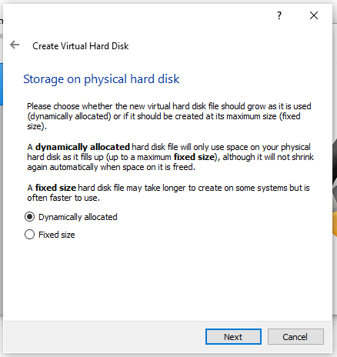

Step 17: You can choose a name for the virtual hard disk along with what location you want to store it. You will also choose a size of the virtual hard disk too (my recommendation is higher than 10 GB, as I set mine to 30 GB). Then click Create:

What you should now see:

Step 18: Double-click on the virtual machine you see above in the right (Ours in this example is “Ubuntu VM1”). You should then see the following below. Then click on the folder icon (red arrow):

Step 19: Then click Add (top left):

Step 20: Click on file you just downloaded, then click “Open”:

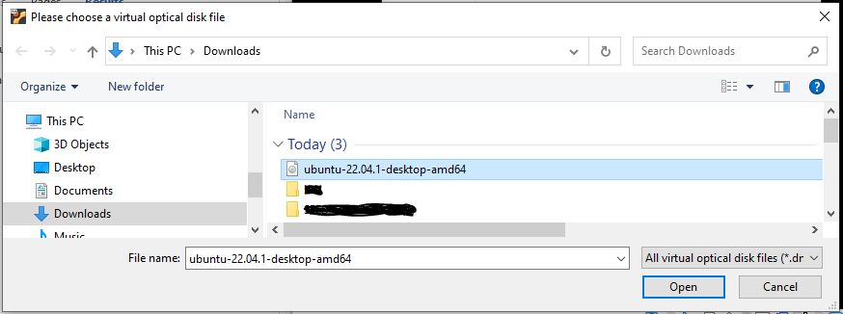

Step 21: Then click Choose:

Step 22: Then click Start:

Step 23: Hit Enter:

Step 24: Your virtual machine will then show the following (make take awhile), where you can now click “Install Ubuntu”:

Step 25: You will see the “Continue” button that is cut-off in the bottom of the window below. Click that “Continue” button (red arrow below):

Step 26: Choose “Minimal installation” (or you can do “Normal installation”), and select both checkboxes for “Other options”. Then click Continue:

Step 27: Click “Install Now”:

Step 28: Then click Continue:

Step 29: Click Continue:

Step 30: Enter your name (“Your computer’s name” and username will autopopulate. You can change both by modifying username) and also enter your password. Then click Continue. Your virtual machine will then install:

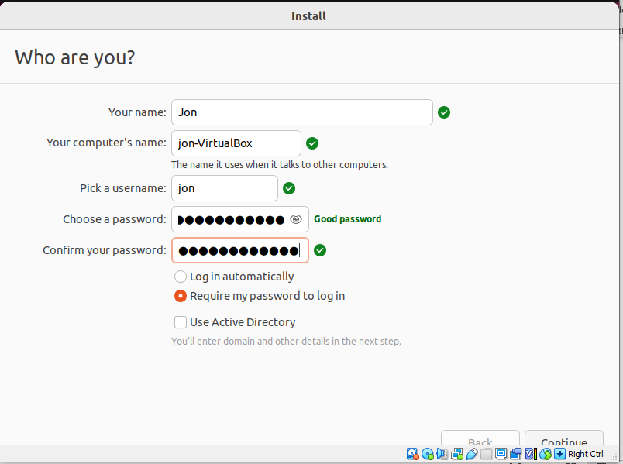

Step 31: Click “Restart Now”:

Step 32: Next click enter, and wait for your virtual machine to load:

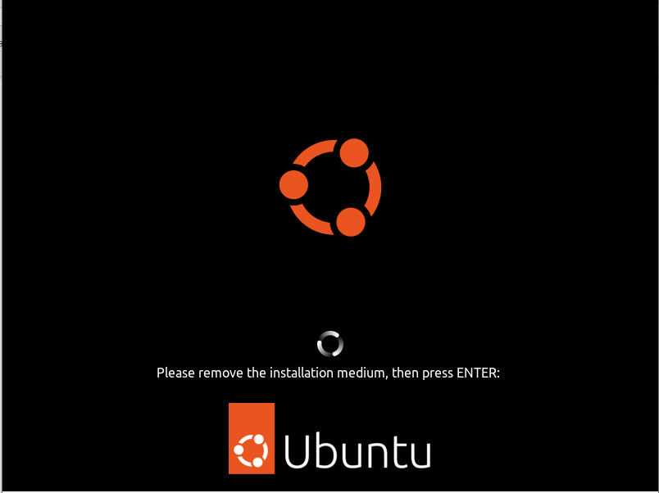

Step 33: Click on your name, then enter your password:

Step 34: Once you hit enter, you will see your virtual machine is now running:

References:

<https://www.virtualbox.org/manual/ch01.html>

<https://www.wikihow.com/Install-VirtualBox>

<https://ubuntu.com/tutorials/how-to-run-ubuntu-desktop-on-a-virtual-machine-using-virtualbox#1-overview>

<https://ubuntu.com/tutorials/how-to-run-ubuntu-desktop-on-a-virtual-machine-using-virtualbox#3-install-your-image>

<https://ubuntu.com/tutorials/how-to-run-ubuntu-desktop-on-a-virtual-machine-using-virtualbox#4-changing-the-window-resolution>

<https://ubuntu.com/tutorials/install-ubuntu-desktop#4-boot-from-usb-flash-drive>

<https://ubuntu.com/tutorials/install-ubuntu-desktop#5-installation-setup>

<https://ubuntu.com/tutorials/install-ubuntu-desktop#6-drive-management>

<https://ubuntu.com/tutorials/install-ubuntu-desktop#10-complete-the-installation>

<https://blog.ldtalentwork.com/2022/02/28/how-to-fix-the-ubuntu-black-screen-issue-in-virtualbox/>